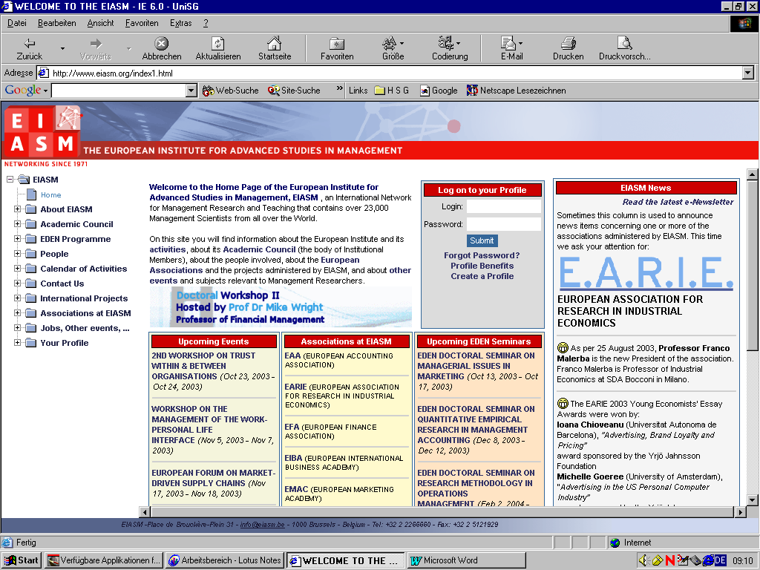PLACE DE BROUCKÈRE-PLEIN - 31 - 1000 BRUSSELS - BELGIUM - Tel: 32 2 2266660 - Fax: 32 2 5121929

WORKSHOP   
ON  
BUSINESS ETHICS  
  
Brussels, Belgium   
  
November 5-6, 2015

P R O G R A M M E

**Thursday, November 5, 2015** 9:00 - 9:30 Registration

9:30 : 10:00 Introduction  
 ***I Business responsibility for the provision of human rights***

10:00 - 10:30 **BUSINESS AND HUMAN RIGHTS: COMMITMENT VERSUS PRACTICE**

*MICHELLE WESTERMANN-BEHAYLO, (UNIVERSITY OF AMSTERDAM – THE NETHERLANDS) – TRICIA OLSEN; KATHLEEN REHBEIN*

10:30 - 11:00 **FROM THE ‘SPHERE OF INFLUENCE’ TO THE ‘SPHERE OF COMPLICITY’: A DYNAMIC MODEL OF BUSINESS RECOGNITION OF HUMAN RIGHTS OBLIGATIONS**

*VAN BUREN III, (UNIVERSITY OF NEW MEXICO – USA) – NICOLE JANZ*

11:00 - 11:15 Coffee/tea break

11:15 – 11:45 **DOES BUSINESS HAVE AN ETHICAL OBLIGATION TO ENHANCE PEACE?**

*KATSOS JOHN, (AMERICAN UNIVERSITY OF SHARJAH - UNITED ARAB EMIRATES) -*

11:45 - 12:15 **THE ROLE OF BUSINESS IN RESPONSIBILITY TO PROTECT (R2P) IN RELATION TO THE GUIDING PRINCIPLES OF BUSINESS AND HUMAN RIGHTS AND CORPORATE SOCIAL RESPONSIBILITY (CSR)**

*NATHAN GANESH, (UNIVERSITY OF APPLIED SCIENCES AND ARTS NORTHWESTERN SWITZERLAND - SWITZERLAND)*

12:15 - 12:45 **ACCOUNTING AND HUMAN RIGHTS: A PRAGMATIC CONSTRUCTIVIST APPROACH**

*PIANEZZI DANIELA, (SANT'ANNA SCHOOL OF ADVANCED STUDIES - ITALY) - LINO CINQUINI*

12:45 - 14:00 lunch

***II CSR: tools, tasks and new directions***

14:00 - 14:30 **BRIBERY CONTROL: STRATEGIC CSR OPTIONS FOR MULTINATIONAL FIRMS**

*AMEER IRFAN, (TURKU SCHOOL OF ECONOMICS - FINLAND) -*

14:30 - 15:00 **RELIGIOSITY AND CORPORATE FINANCIAL REPORTING**

*BARBOSA TANIA, (MINHO UNIVERSITY / SCHOOL OF ECONOMICS AND MANAGEMENT - PORTUGAL)*

15:00 - 15:30 Coffee Break

15:30 - 16:00 **WHAT DO EMERGING ECONOMY FIRMS ACTUALLY DISCLOSE IN THEIR CSR REPORTS? A LONGITUDINAL ANALYSIS**

*CORCIOLANI MATTEO, (UNIVERSITY OF PISA - ITALY) - CORCIOLANI, MATTEO; DALLI, DANIELE;GANDOLFO, ALESSANDRO;GIULIANI, ELISA; TUAN, ANNAMARIA*

16:00 - 16: 30 **CORPORATE COMMUNICATION OF SOCIAL RESPONSIBILITY AND MORAL LEGITIMACY***LEE JANET, (THE AUSTRALIAN NATIONAL UNIVERSITY - AUSTRALIA) - JULIANA NG*

16:30 – 17:00 **REVISITING THE LINK BETWEEN CORPORATE SOCIAL RESPONSIBILITY (CSR) AND**

**FINANCIAL PERFORMANCE: THE ROLE OF CSR PERSISTENCE** *REVILLA ANTONIO, (CARLOS III UNIVERSITY, MADRID - SPAIN) - CARMEN LESCANO*

**Friday, November 6, 2015**

***III Management, governance and new business models***

9:00 - 9:30 **ETHICAL LEARNING IN MANAGEMENT EDUCATION: EUROPEAN ETHICAL COMPETENCES** *HERNANDEZ LIDIA, (UNIVERSITY OF LAS PALMAS DE GRAN CANARIA - SPAIN) - PETRA DE SAÁ PÉREZ*

9:30 - 10:00 **COMPLEMENTARY OR SUBSTITUTIVE EFFECTS? CORPORATE GOVERNANCE, EQUIFINALITY AND CORPORATE SOCIAL RESPONSIBILITY** *OH WONYONG, (UNIVERSITY OF CALGARY - CANADA) - CHANG, Y.K. AND KIM T.Y.*

10:00 - 10:30 Coffee break

10:30 - 11:00 **INCLUSIVE BUSINESS: TOWARDS A CONCEPTUAL FRAMEWORK AND RESEARCH AGENDA** *CURTIS SALLY, (THE AUSTRALIAN NATIONAL UNIVERSITY - AUSTRALIA) - ANDREW PENN BRADLY*

11:00- 11:30 **A NORMATIVE ANALYSIS OF THE SHARING ECONOMY THE UBER CASE**

*BOSHUIJZEN- VAN BURKEN CHRISTINE, (VAEXJOE UNIVERSITY - SWEDEN) - DAREK M. HAFTOR*

11:30 - 12:00 **THE DANCE WITHIN: A NEW PERSPECTIVE TO TACKLE SUSTAINABILITY CHALLENGES**

*CAMPOS MARQUES ANA CRISTINA, (RADBOUD UNIVERSITY - NETHERLANDS) - MARJA FLORY*

12:00 - 13:45 lunch

***IV Social roles of business***

13:30 – 14:00 **WHEN PRIVATE FIRMS PROVIDE PUBLIC GOODS: A CONCEPTUAL MODEL OF POLITICAL CSR IN DEVELOPING COUNTRIES**

*BRADLY ANDREW, (THE AUSTRALIAN NATIONAL UNIVERSITY - AUSTRALIA)*

14:00 - 14:30 **FIRMS IN PARENTAL JUSTICE**

*BLANC SANDRINE, (INSEEC BUSINESS SCHOOL - FRANCE) - TIM MEIJERS*

14:30 - 15:00 **DILEMMAS IN SOCIAL PARTNERSHIPS: A CONVERSATION ANALYTIC PERSPECTIVE**

*NGUYEN TOTRAN, (K.U.LEUVEN - BELGIUM) - MADDY JANSSENS*

15:00 - 15:15 coffee break

15:15 - 15:45 **EMANCIPATING RESEARCH ON SOCIAL ENTREPRENEURSHIP**

*PESSANHA GOMES CATARINA, (COPENHAGEN BUSINESS SCHOOL - DENMARK)*

15:45 - 16:15 Conclusions and lessons learned